SIMATS ENGINEERING
ASSESSMENT TOOL 2
COURSE NAME: Fundamentals of Data Science COURSE CODE: DSA04
COURSE OUTCOME COVERED
CO4: Develop machine learning models for classification, regression, and clustering, including performance evaluation and methodology comparison. (BL3)
Assessment Tool Weightage: 30%
QUESTIONS: 01 Total Marks:100 Annexure A
Industry Problem Solving
Code of Conduct:
I Anto Chriswin G (192324093) (Name / Reg No) certify that this submission is my original work and that I have adhered to the guidelines specified for this assessment.
I understand that any violation of academic integrity rules will result in disciplinary action.
Signature of the student:

RUBRICS FOR CALCULATION
SCENARIO BASED ASSESSMENT
Criteria | Weightage  (%) | Level 4  (Exemplary) | Level 3  (Proficient) | Level 2  (Developing) | Level 1  (Beginning) | Level | Marks
Understanding of Scenario | 20% | Demonstrates clear and complete  understanding of the scenario and  context | Shows good  understanding  with minor gaps | Partial  understanding;  misses key  aspects | Misinterprets or fails to  understand the scenario
Identification of Key Issues | 20% | Accurately  identifies all  relevant issues and factors involved | Identifies most  key issues with minor omissions | Identifies limited issues; some  irrelevant points | Unable to  identify key  issues
Application of Concepts | 25% | Applies appropriate concepts effectively to address the  scenario | Applies concepts with minor errors | Limited or  partially correct application | Unable to apply relevant  concepts
Decision  Making | 20% | Makes well  reasoned, logical decisions with  strong rationale | Makes  reasonable  decisions with  some  justification | Makes weak  decisions with  limited  justification | No clear  decisions made or rationale  provided
Clarity of  Response | 15% | Response is clear, structured, and  logically presented | Generally clear with minor issues | Somewhat unclear or poorly  structured | Disorganized  and difficult to understand

Question 7: Healthcare Treatment Cost Prediction Using Lasso Regression
A hospital wants to predict treatment cost based on patient health parameters. Since many medical features are available, the hospital wants to use Lasso Regression to identify important predictors.
Patient Age BP Sugar Level BMI Previous Visits Treatment Cost
P1 25 115 90 22 1 5000
P2 35 125 110 25 2 8000
P3 45 140 150 29 3 15000
P4 55 155 180 32 5 25000
P5 60 165 200 35 6 32000
P6 30 120 100 24 1 7000
P7 50 150 170 31 4 22000
P8 40 135 130 27 2 12000

Tasks
a) Create the dataset using Python.
b) Identify features and target variable.
c) Split into training and testing sets.
d) Implement Lasso Regression.
e) Try alpha values such as 0.1, 1.0, and 10.0.
f) Predict treatment cost for test patients.
g) Predict treatment cost for a new patient:
Age BP Sugar Level BMI Previous Visits
48 145 160 30 4
h) Evaluate using MAE, MSE, RMSE, and R2 score.
i) Print the model coefficients.
j) Explain which medical features are important based on Lasso coefficients.
Code :
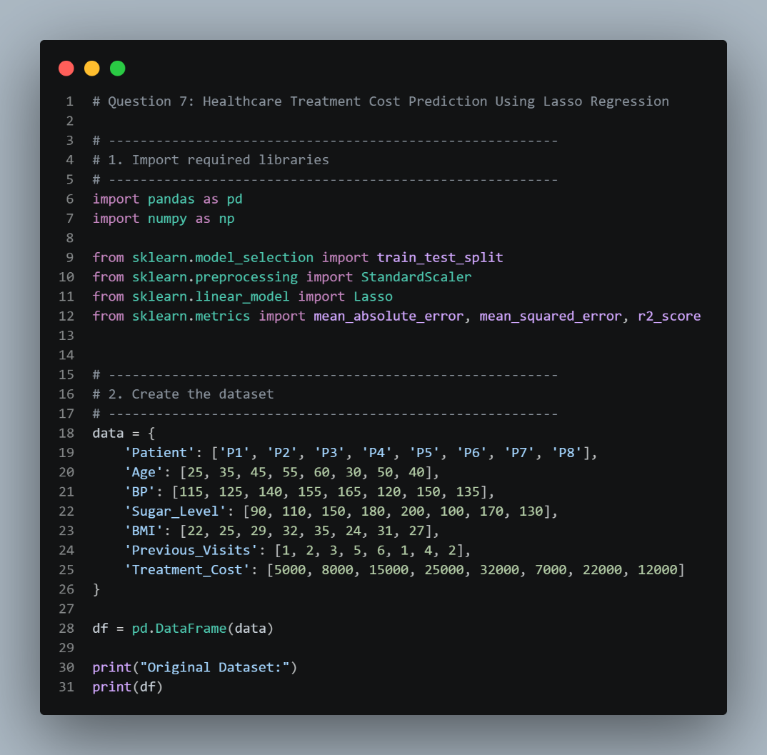

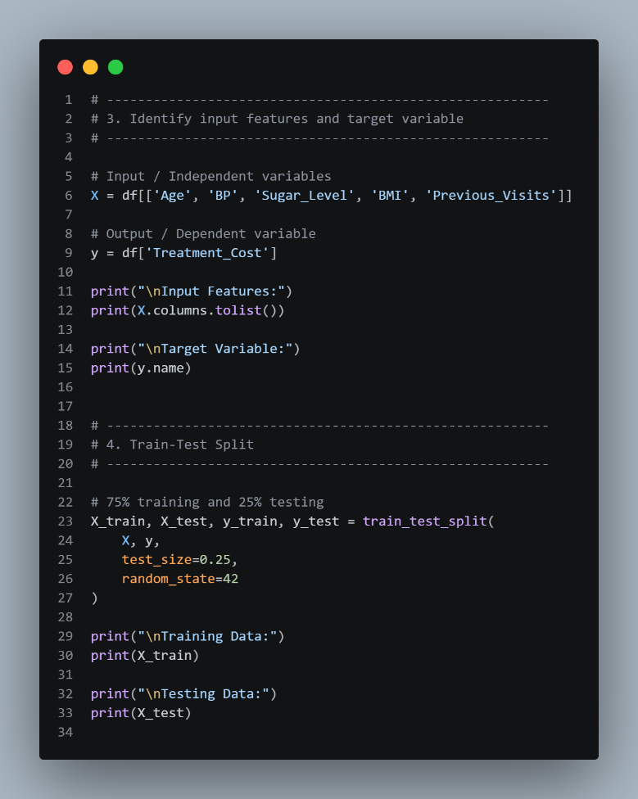

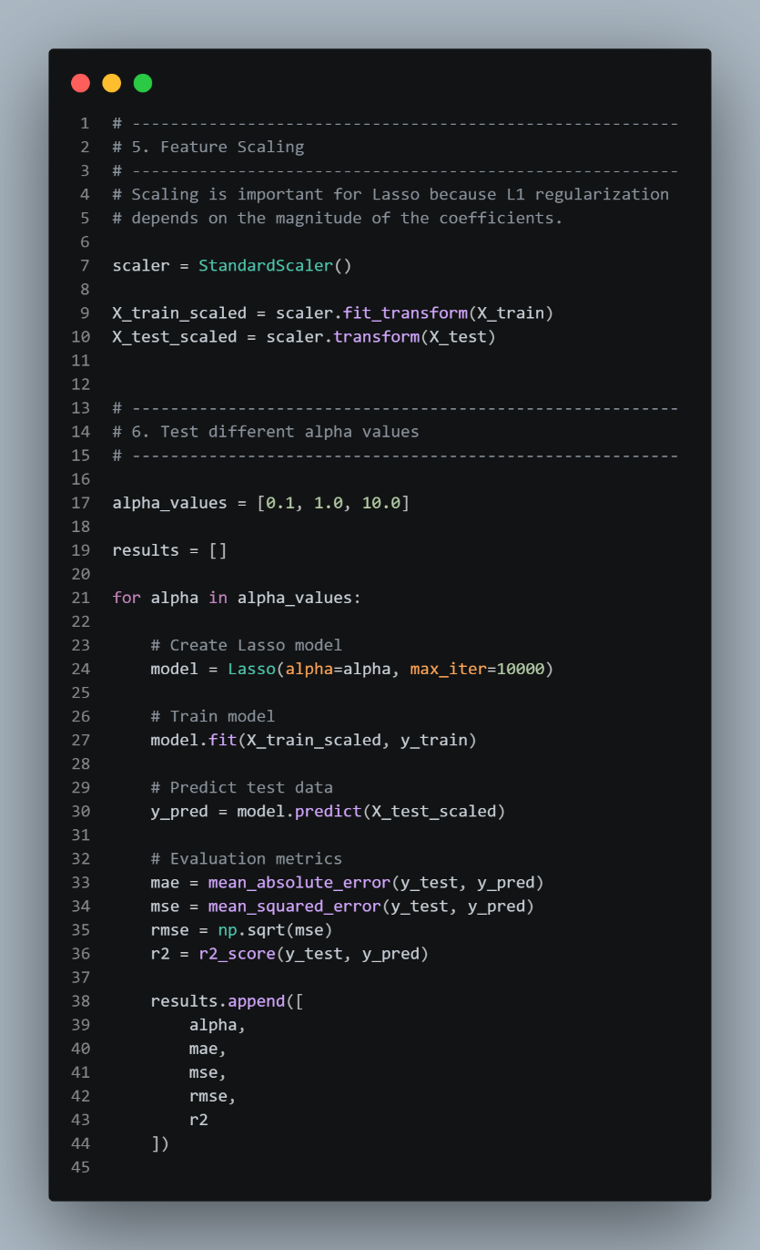

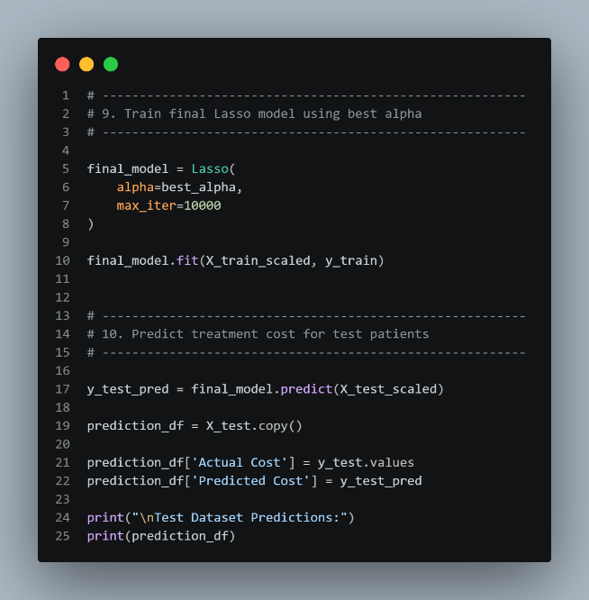
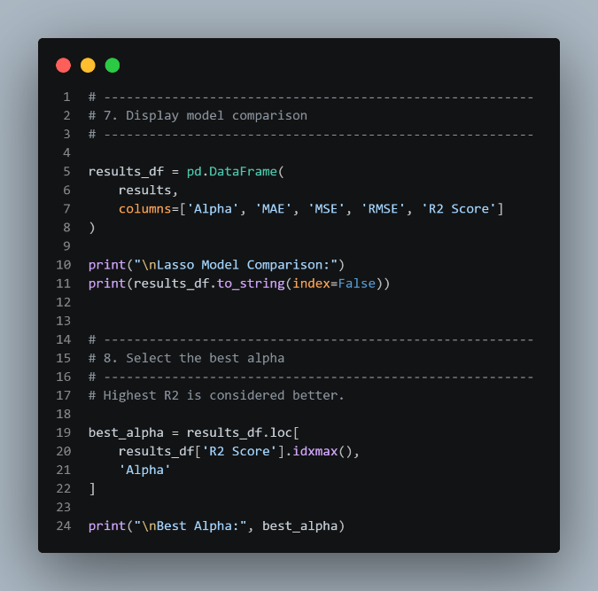

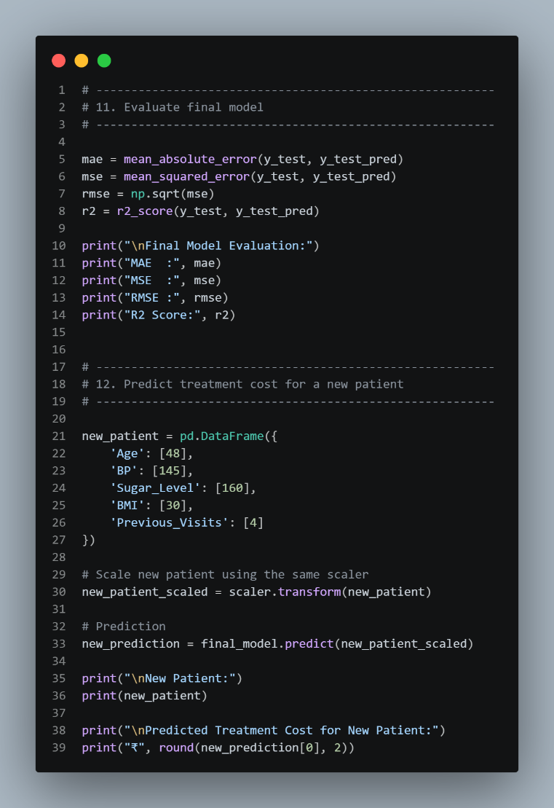
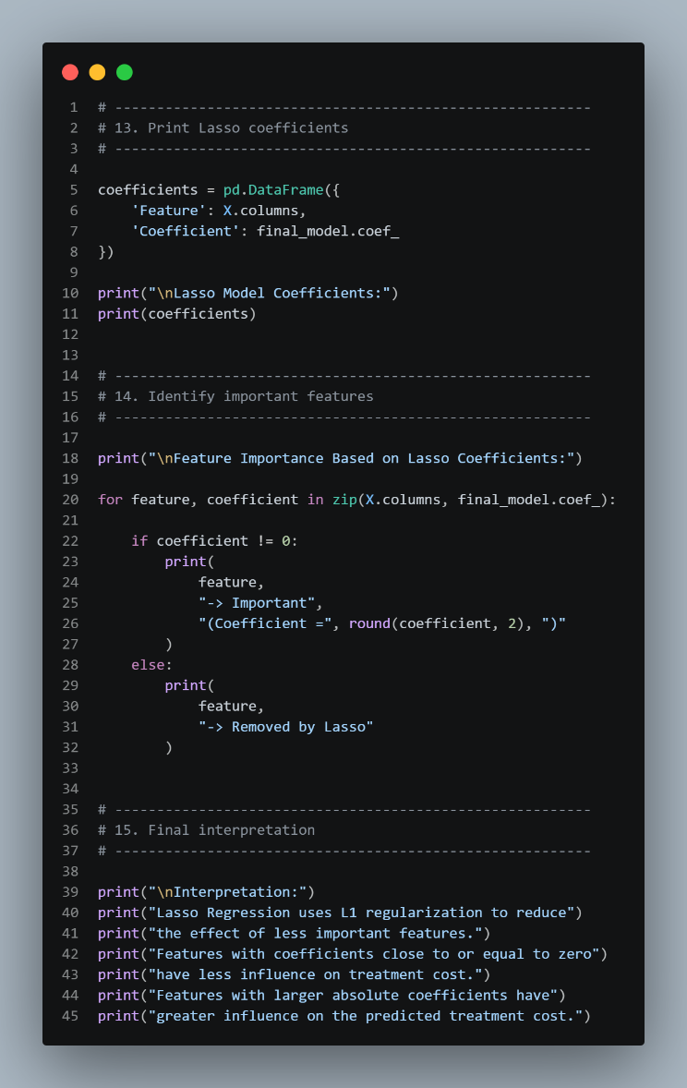

Output:
